苏州大学实验报告

|  |  |  |  |  |  |  |  |  |  |  |
| --- | --- | --- | --- | --- | --- | --- | --- | --- | --- | --- |
| 院、系 | 计算机学院 | | 年级专业 | | 计算机类 | | 姓名 | 娄陈 | 学号 | 1727405150 |
| 课程名称 | | 数字电路与数字系统设计 | | | | | | | 成绩 |  |
| 指导教师 | |  | | 同组实验者 | | 无 | | 实验日期 | 2018.10.22 | |

|  |  |
| --- | --- |
| 实 验 名 称 | 实验二 译码器和数码显示器实验 |

1. 实验目的
   1. 掌握74LS138 3-8译码器的逻辑功能
   2. 掌握CD4511型7段BCD译码器的逻辑功能
2. 实验设备
   1. TD-DS+/TD-DS实验箱一台
   2. 74LS138 3线-8线译码器一片
   3. CD4511 BCD-7段译码器/驱动器1片
3. 实验步骤

**1.74LS138 3-8译码器逻辑功能验证**

按如图所示方法接线，输入端接逻辑开关，输出端接逻辑电平显示，根据逻辑功能表输入，讲测试结果填表。

**逻辑电平开关 逻辑电平显示**



**图2-2-1 3-8译码器线路图**

**表2-2-2 74LS138实验记录表**

|  |  |  |  |  |  |  |  |  |  |  |  |  |  |
| --- | --- | --- | --- | --- | --- | --- | --- | --- | --- | --- | --- | --- | --- |
| 输 入 | | | | | | 输 出 | | | | | | | |
| 门控 | | | 输入 | | | Y7 | Y6 | Y5 | Y4 | Y3 | Y2 | Y1 | Y0 |
| S3 S2 S1 | | | C B A | | |  |  |  |  |  |  |  |  |
| 0 | 0 | 1 | 0 | 0 | 0 |  |  |  |  |  |  |  |  |
| 0 | 0 | 1 | 0 | 0 | 1 |  |  |  |  |  |  |  |  |
| 0 | 0 | 1 | 0 | 1 | 0 |  |  |  |  |  |  |  |  |
| 0 | 0 | 1 | 0 | 1 | 1 |  |  |  |  |  |  |  |  |
| 0 | 0 | 1 | 1 | 0 | 0 |  |  |  |  |  |  |  |  |
| 0 | 0 | 1 | 1 | 0 | 1 |  |  |  |  |  |  |  |  |
| 0 | 0 | 1 | 1 | 1 | 0 |  |  |  |  |  |  |  |  |
| 0 | 0 | 1 | 1 | 1 | 1 |  |  |  |  |  |  |  |  |

**2.BCD-7段译码器功能验证**

实验采用CD4511七段译码器驱动器驱动共阴极数码管。按照图示连接实验电路，将A、B、C、D接逻辑开关，输出端接七段数码管显示单元中无译码器数码管对应引脚，SEG0接地。验证CD4511七段译码器功能

（注：实验中才有用TD-DS+实验箱的同学用SEG2-SEG5均可。）

记录数据结果，设计表格时注意高位在前。

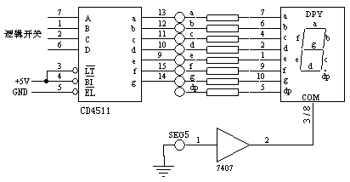

**图2-2-3 BCD-7段译码器功能验证线路**

1. 实验结果

74LS138实验记录表

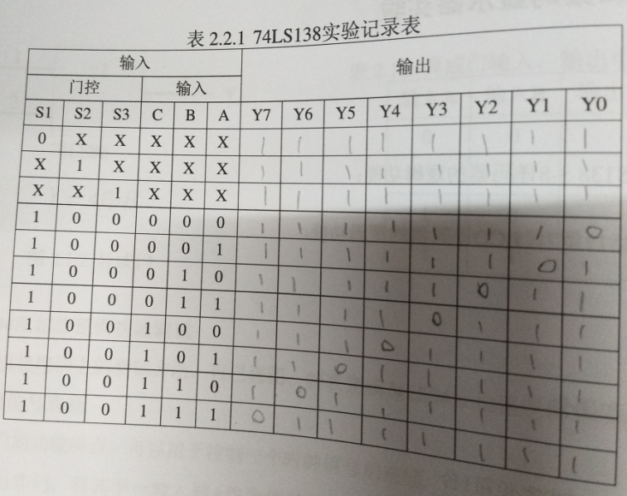

**表2-2-4 BCD码到七段显示码的转换表（电子表）**

|  |  |  |  |  |  |  |  |  |  |  |  |  |
| --- | --- | --- | --- | --- | --- | --- | --- | --- | --- | --- | --- | --- |
| BCD码 | | | | 七段显示码 | | | | | | | | |
| S4 | S3 | S2 | S1 | G | F | E | D | C | B | A | NUM | 数码管显示值 |
| 0 | 0 | 0 | 0 | 0 | 1 | 1 | 1 | 1 | 1 | 1 | 3F | 0 |
| 0 | 0 | 0 | 1 | 0 | 0 | 0 | 0 | 1 | 1 | 0 | 06 | 1 |
| 0 | 0 | 1 | 0 | 1 | 0 | 1 | 1 | 0 | 1 | 1 | 5B | 2 |
| 0 | 0 | 1 | 1 | 1 | 0 | 0 | 1 | 1 | 1 | 1 | 4F | 3 |
| 0 | 1 | 0 | 0 | 1 | 1 | 0 | 0 | 1 | 1 | 0 | 66 | 4 |
| 0 | 1 | 0 | 1 | 1 | 1 | 0 | 1 | 1 | 0 | 1 | 6D | 5 |
| 0 | 1 | 1 | 0 | 1 | 1 | 1 | 1 | 1 | 0 | 1 | 7D | 6 |
| 0 | 1 | 1 | 1 | 0 | 0 | 0 | 0 | 1 | 1 | 1 | 07 | 7 |
| 1 | 0 | 0 | 0 | 1 | 1 | 1 | 1 | 1 | 1 | 1 | 7F | 8 |
| 1 | 0 | 0 | 1 | 1 | 1 | 0 | 1 | 1 | 1 | 1 | 6F | 9 |

实际做表

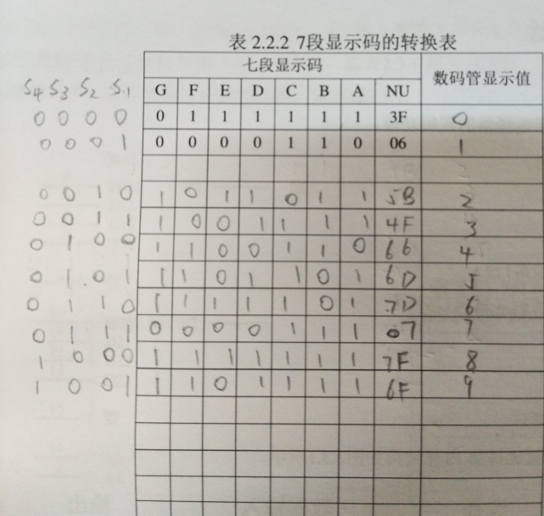

**BCD-7段译码器功能验证**

**实验中的一个连线情况**

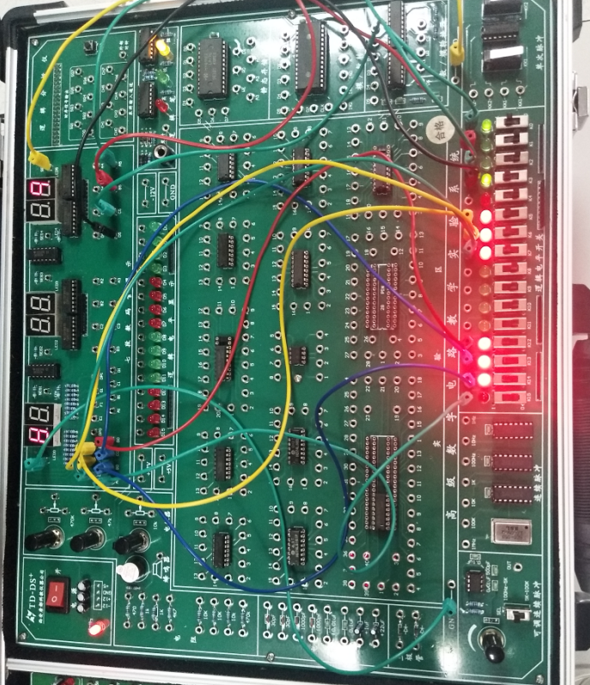

1. 实验体会

这一次的连线比上一个实验明显有难度，但是由于有上一个实验所学到的基础知识，所以这个实验将电路图看懂了那么连接实物图就会变得很简单的。对74LS138 3-8译码器的逻辑功能有了更加多的了解，掌握CD4511型7段BCD译码器的逻辑功能，对数字电路有了更加深入的了解。